

**Experimental Lab Student Report**

Week 6 Lab

Lab Title: Text Editors and the Command Line

Student Name: Anthony Meunier

Date: 2/10/2014

After completing the activities, take a screenshot of the following and copy onto this report:

1. Activity 8-3, after #13 (6 points)

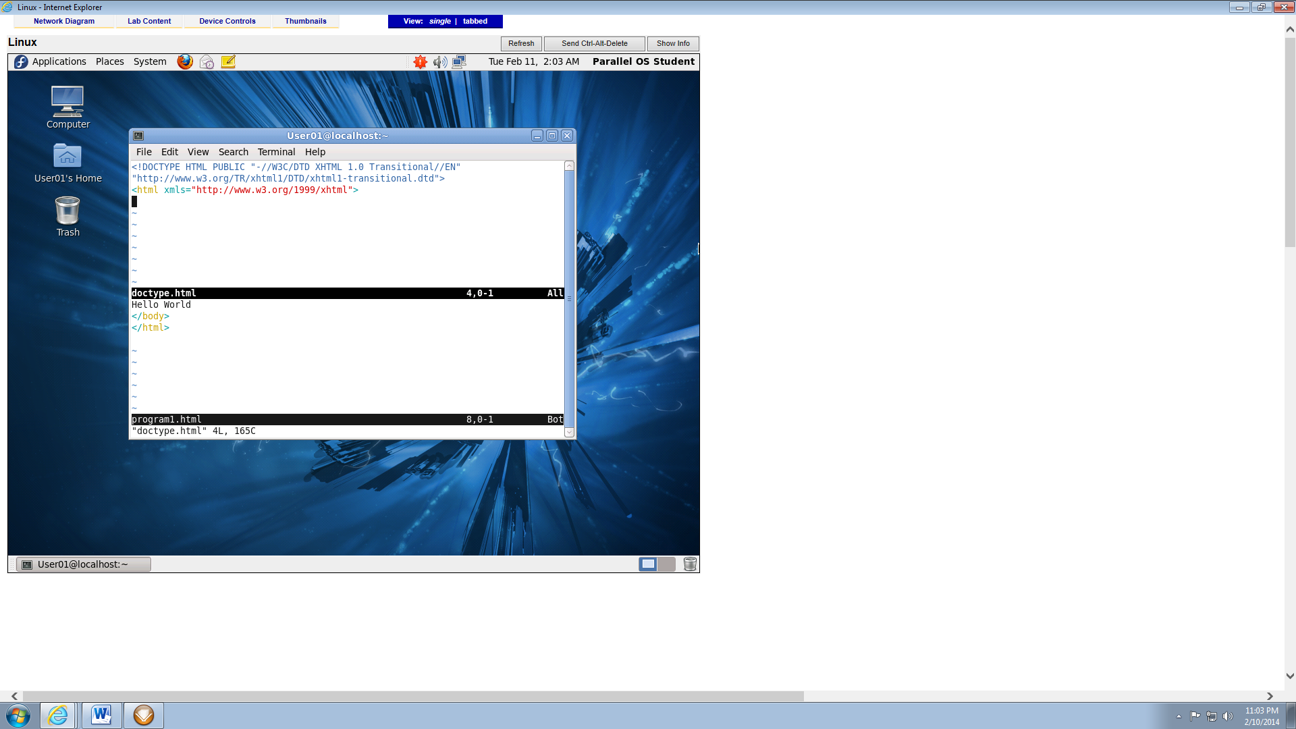

1. Activity 8-11, after #7 (6 points)

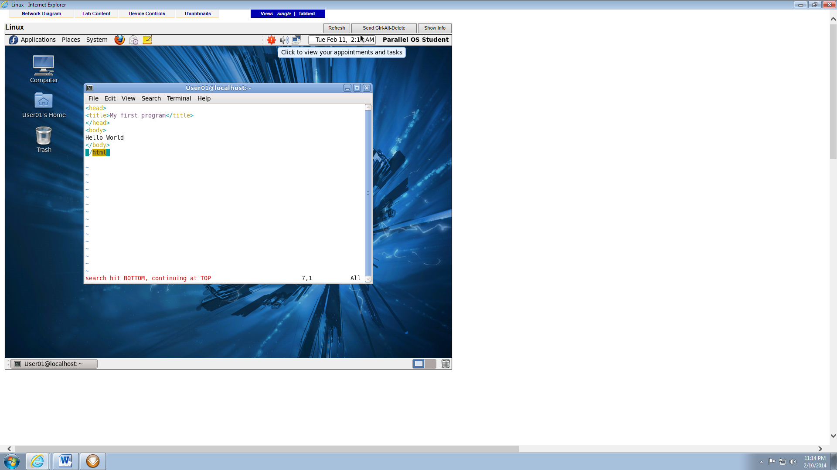

1. Activity 8-12, after #18. (6 points)

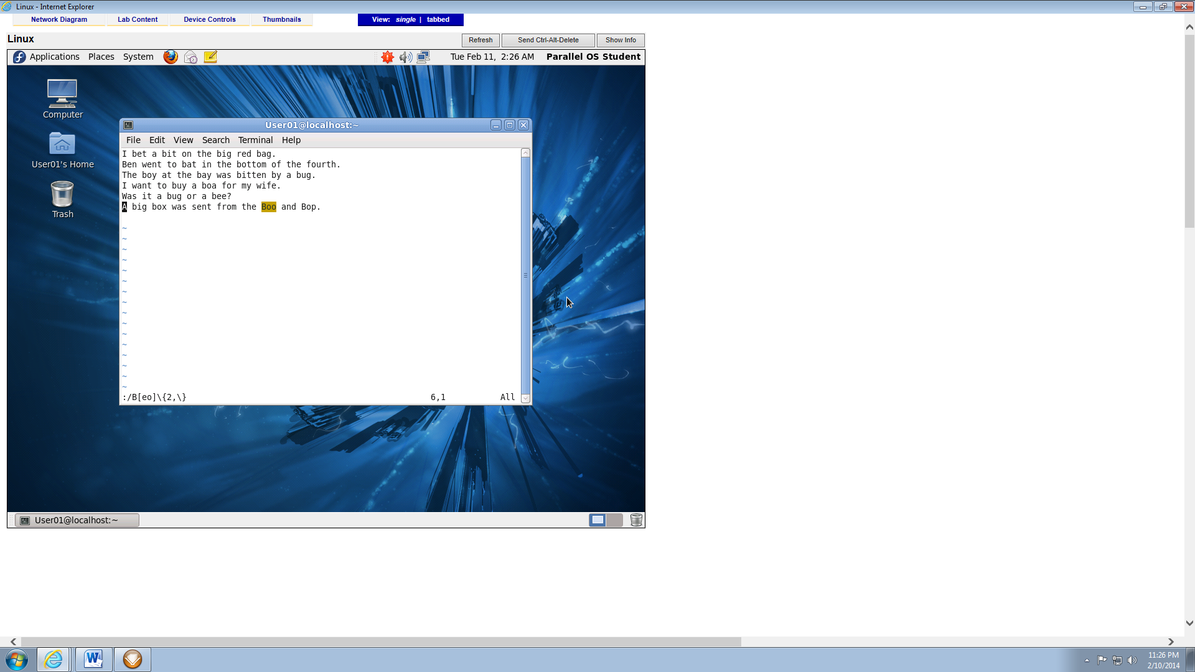

1. Activity 8-16, after #14 (6 points)

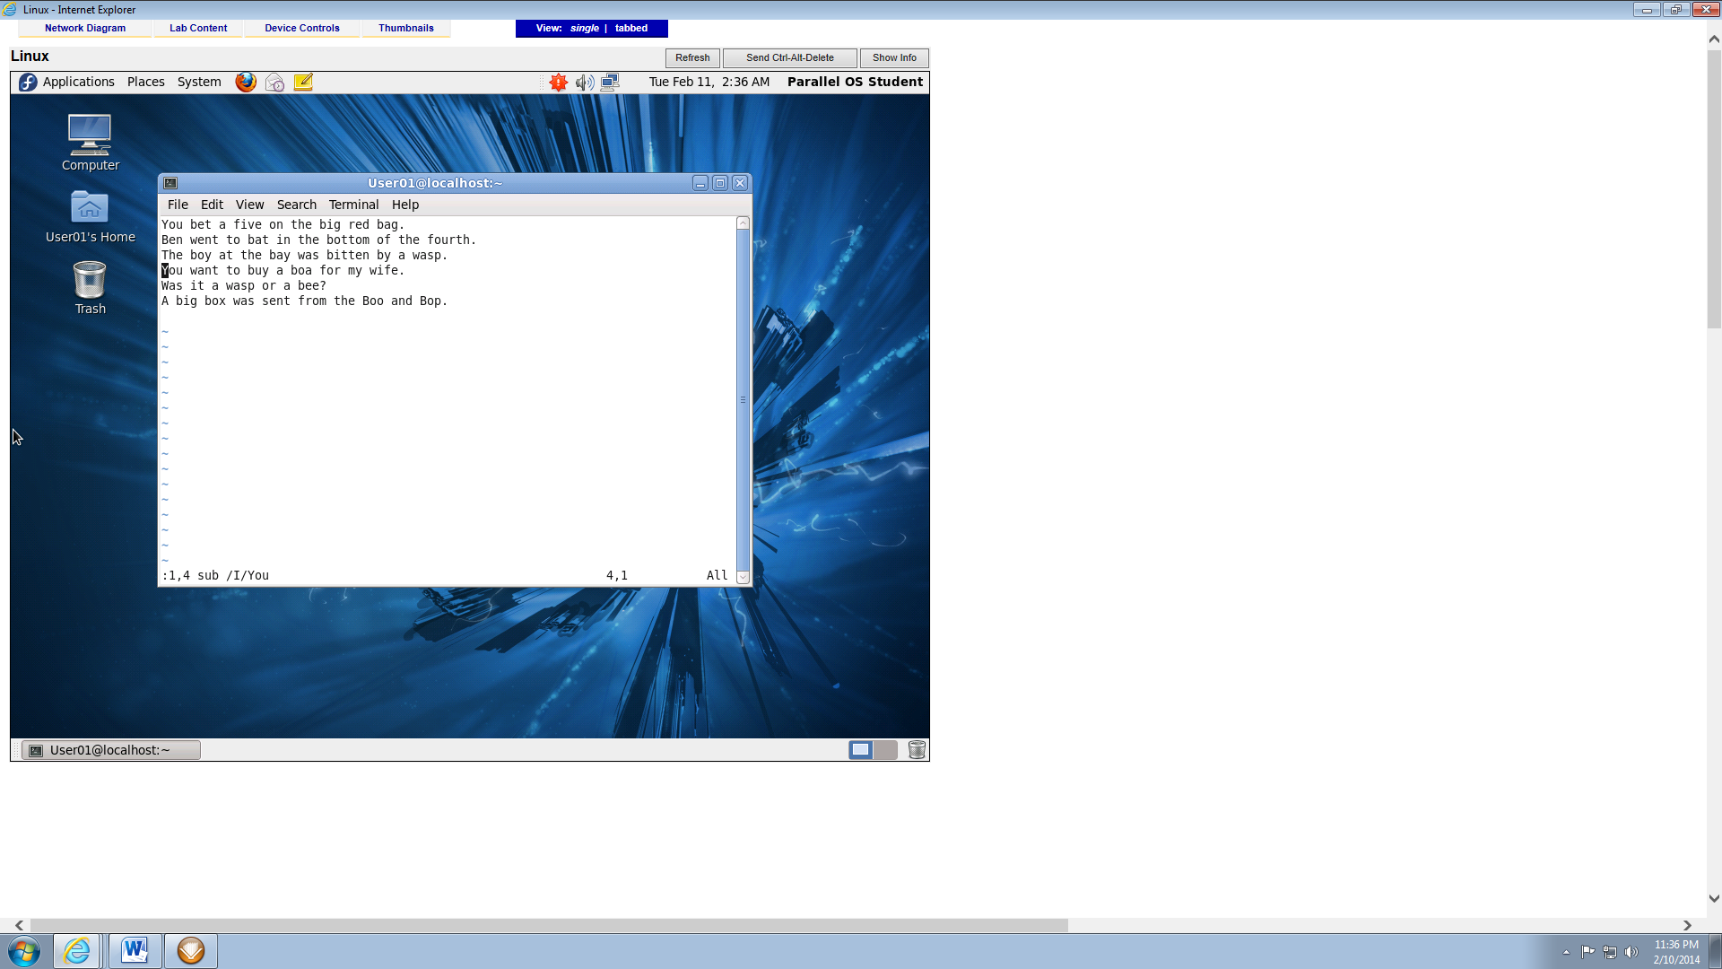

1. Activity 9-9, after #7 (6 points)

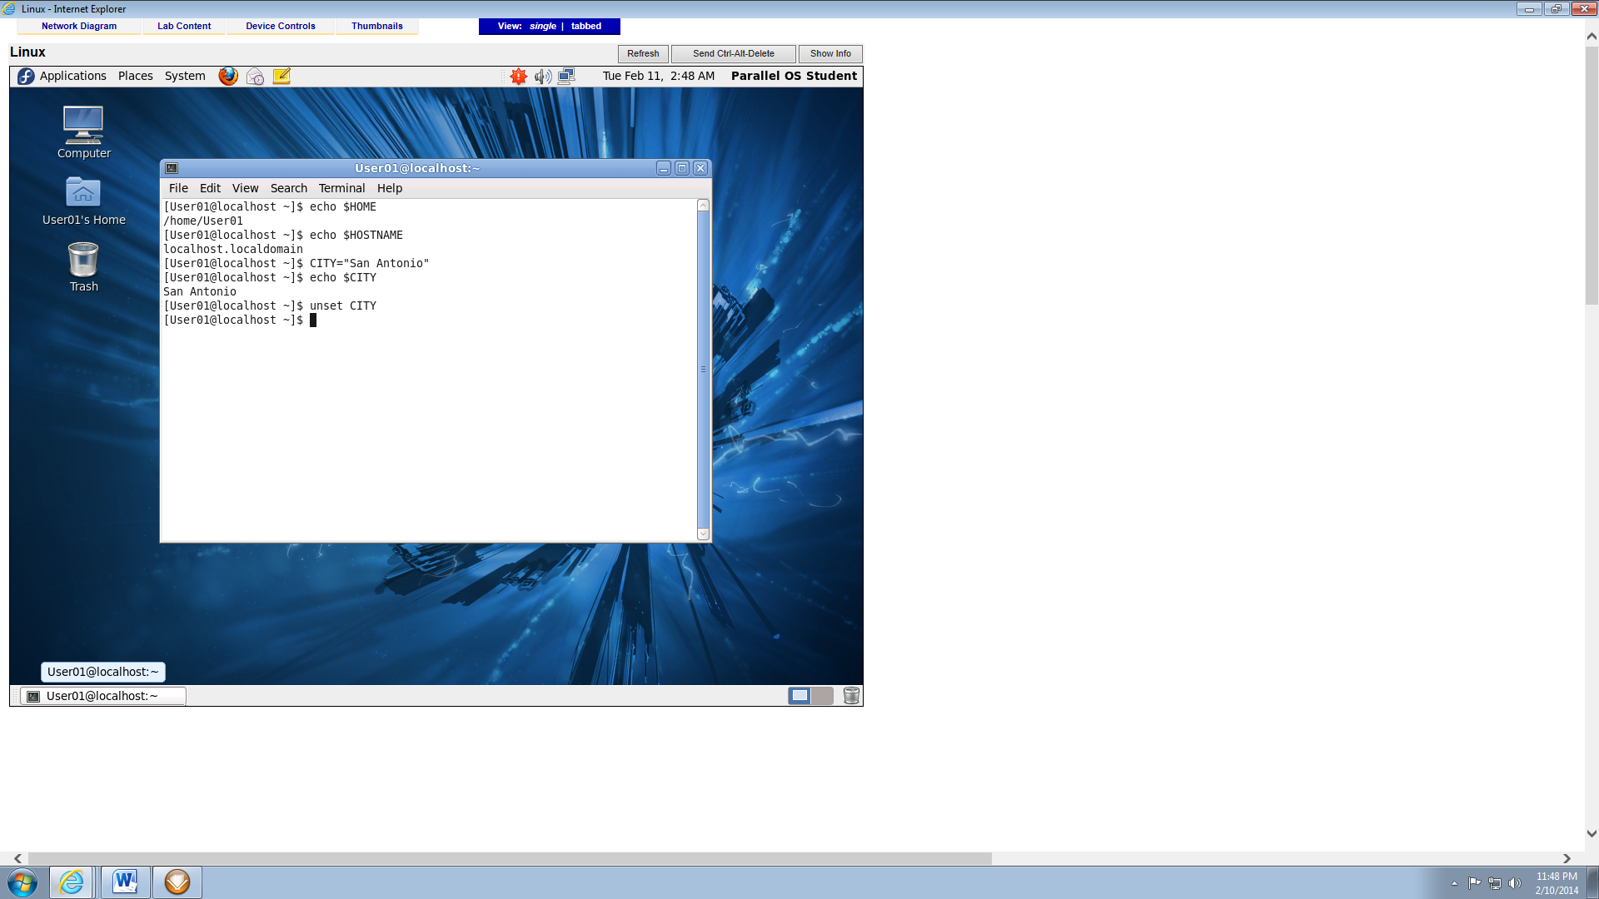

1. Activity 9-17, after #15. Expand the DOS window to be able to see the command and the results (6 points)

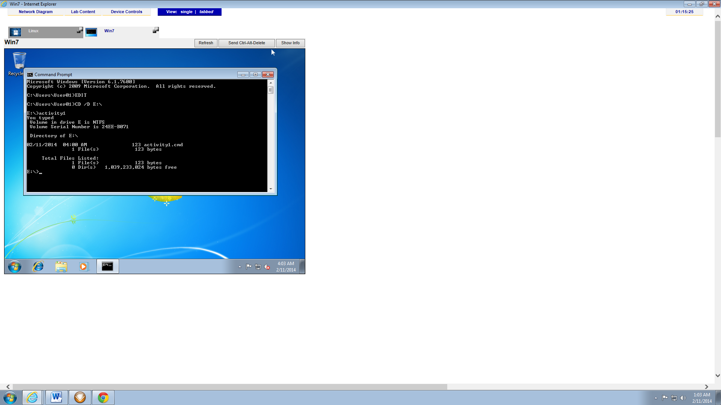

1. Activity 9-17, after #31 (7 points)

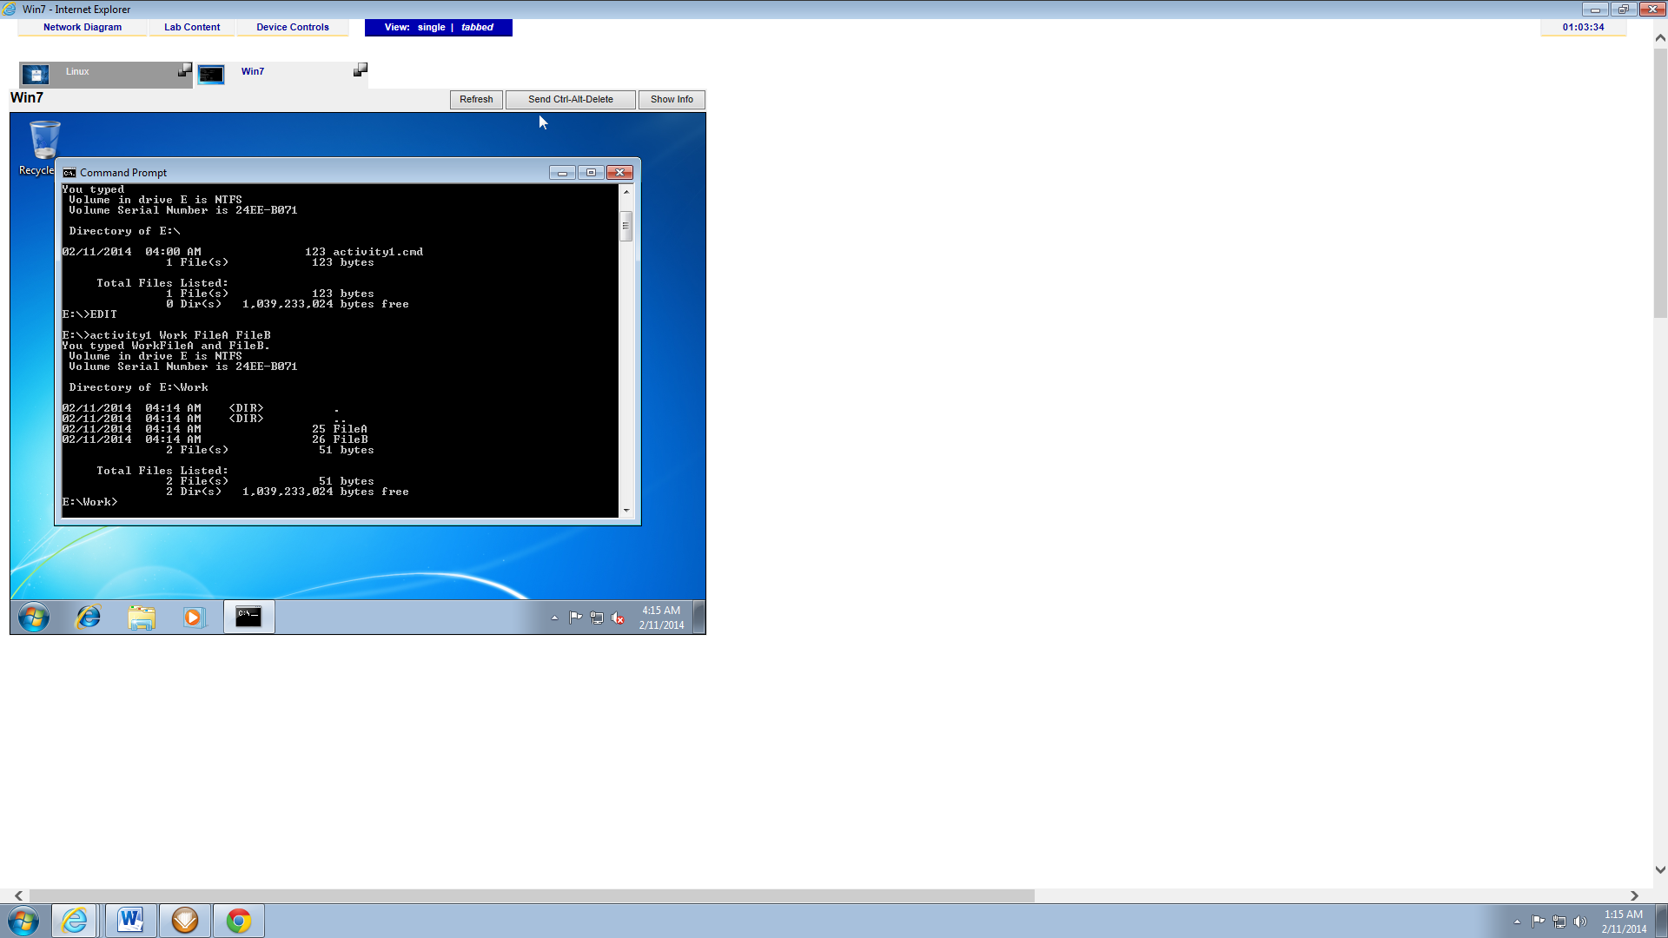

1. Activity 9-19, after #19 (7 points)

